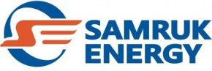

Kazakhstan’s Power Sector Market Analysis
January–DeCEMBER 2025

Prepared by: Market Analysis and Development Department
Contact details: 8 (7172) 55-30-67

JANUARY 2026

Contents
1. Electricity generation in Kazakhstan’s UPS 3
1.1 Electricity generation by "Samruk-Energy" JSC power-producing companies..…….……..3
2.1. Performance results of the industrial sector for January–December 2025.……………..4
2.2 Electricity consumption by zones 5
Coal ……………………………………………………………………………….……………………………….
3. Renewable energy sources 6
3.1 Target indicators for RES 6
3.2 RES indicators in the RK 6
3.3 Role of Samruk-Energy JSC in clean electricity generation 7

Electricity generation in Kazakhstan’s UPS

According to the System Operator, power plants in the Republic of Kazakhstan generated 123 110,9 mln. kWh of electricity in January–December 2025, which is 5 195,5 thous. kWh, or 4,4 %, higher than in the same period of 2024.
mln.kWh
No. | Zone | Generation type | January-December |  | Δ  mln.kWh | Δ, %
No. | Zone | Generation type | 2024 | 2025 | Δ  mln.kWh | Δ, %
 | Kazakhstan | Total | 117 915,4 | 123 110,9 | 5 195,5 | 4,4
 | Kazakhstan | TPP | 88 377,8 | 91 650,8 | 3 273,0 | 3,7
 | Kazakhstan | GTPP | 11920,4 | 13489,2 | 1568,8 | 13,2
 | Kazakhstan | HPP | 11 223,4 | 10 493,8 | -729,6 | -6,5
 | Kazakhstan | WPP | 4 497,6 | 5 400,7 | 903,1 | 20,1
 | Kazakhstan | SPP | 1 895,6 | 2 074,6 | 179,0 | 9,4
 | Kazakhstan | BGP | 0,6 | 1,8 | 1,2 | 200,0
1 | Northern | Total | 86 489,7 | 88 968,0 | 2 478,3 | 2,9
1 | Northern | TPP | 72 725,5 | 74 711,9 | 1 986,4 | 2,7
1 | Northern | GTPP | 3 176,0 | 3 241,5 | 65,5 | 2,1
1 | Northern | HPP | 7 389,1 | 7 046,2 | -342,9 | -4,6
1 | Northern | WPP | 2 627,8 | 3 347,8 | 720,0 | 27,4
1 | Northern | SPP | 570,7 | 618,8 | 48,1 | 8,4
1 | Northern | BGP | 0,6 | 1,8 | 1,2 | 200,0
2 | Southern | Total | 15 565,7 | 16 224,3 | 658,6 | 4,2
2 | Southern | TPP | 8 649,7 | 9 387,9 | 738,2 | 8,5
2 | Southern | HPP | 3 834,3 | 3447,6 | -386,7 | -10,1
2 | Southern | GTPP | 203,8 | 388,8 | 185,0 | 90,8
2 | Southern | WPP | 1556,2 | 1559,8 | 3,6 | 0,2
2 | Southern | SPP | 1321,7 | 1440,2 | 118,5 | 9,0
3 | Western | Total | 15860,0 | 17918,6 | 2058,6 | 13,0
3 | Western | TPP | 7002,6 | 7551,0 | 548,4 | 7,8
3 | Western | GTPP | 8540,6 | 9858,9 | 1318,3 | 15,4
3 | Western | WPP | 313,6 | 493,1 | 179,5 | 57,2
3 | Western | SPP | 3,2 | 15,6 | 12,4 | 387,5

1.1 Electricity generation by Samruk-Energy JSC’s power-producing companies

In January–December 2025, Samruk-Energy JSC’s power producing companies generated 40 436,3 mln kWh of electricity, the increase in electricity generation compared to the same period in 2024 amounted to 39 772,3 mln. kWh, or 1,7%.
mln.kWh
No. | Name | 2024 |  | 2025 |  | Δ 2025/2024
No. | Name | January-December | Share in the RK, % | January-December | Share in the RK, % | mln.kWh | %
 | “Samruk-Energy” JSC | 39 772,3 | 33,7% | 40 436,3 | 32,8% | 664,0 | 1,7%
1 | “APP” JSC | 5 195,9 | 4,3% | 5 121,3 | 5,6% | -74,6 | -1,4%
2 | Ekibastuz SDPP-1 LLP | 22 543,7 | 19,1% | 24 572,9 | 20,0% | 2 029,2 | 9,0%
3 | Ekibastuz SDPP-2 JSC | 6 045,2 | 5,1% | 5 246,2 | 4,3% | -799,0 | -13,2%
4 | Shardarinskaya HPP JSC | 583,4 | 0,5% | 436,0 | 0,4% | -147,4 | -25,3%
5 | Moynak HPP JSC | 1 070,6 | 0,9% | 979,0 | 0,8% | -91,6 | -8,6%
6 | Samruk-Green Energy LLP | 21,0 | 0,0% | 21,1 | 0,0% | 0,09 | 0,4%
7 | Shelek WPP of Energia Semirechya LLP | 227,3 | 0,2% | 211,6 | 0,2% | -15,69 | -6,9%
8 | First Wind Power Plant LLP | 137,3 | 0,1% | 149,3 | 0,1% | 12,0 | 8,7%
9 | AES Ust-Kamenogorsk HPP LLP | 1891,2 | 1,6% | 1 827,4 | 1,5% | -63,8 | -3,4%
10 | AES Shulbinsk HPP LLP | 2 056,7 | 1,7% | 1 871,5 | 1,5% | -185,2 | -9,0%

- Electricity consumption in Kazakhstan’s UPS

2.1. Performance results of the industrial sector for January–December 2025

In January–December 2025, Kazakhstan’s Industrial Production Index (IPI) reached 107,5%.
Output increased by 9,4% in mining, 6,4 % in manufacturing, and 2,1% in the supply of electricity, gas, steam, hot water and air conditioning.
The strongest growth was recorded in Atyrau, Zhambyl, North Kazakhstan, and Turkistan regions, as well as in Almaty and Shymkent cities.

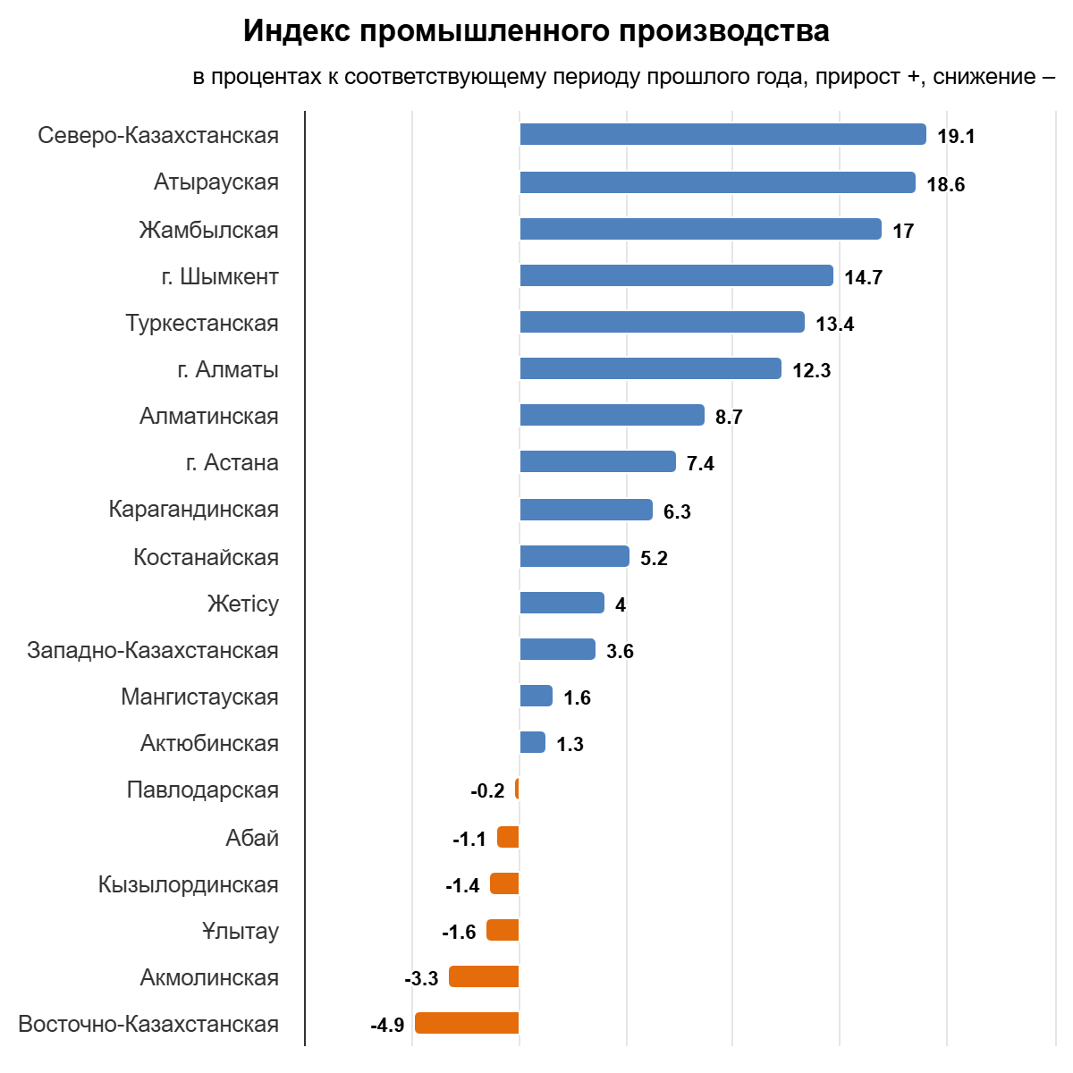

2.2 Electricity consumption by zones

According to the System Operator, an upward trend was observed in electricity consumption in the Republic in January–December 2025 compared to the same period of 2024, with an increase of 4 611 million kWh, or 3,8%. In particular, electricity consumption rose by 13.2%, 8%, and 0.3% in the western, southern, and northern zones of the Republic, respectively. mln.kWh

No. | Description | January-December |  | Δ,  mln.kWh | Δ, %
No. | Description | 2024 | 2025 | Δ,  mln.kWh | Δ, %
 | Kazakhstan | 119 995,5 | 124 606,5 | 4 611,0 | 3,8
1 | Northern zone | 75 335,4 | 75 540,6 | 205,2 | 0,3
2 | Western zone | 16 283,3 | 18 424,9 | 2 141,6 | 13,2
3 | Southern zone | 28 376,9 | 30 641,0 | 2 264,1 | 8,0
 | Including by regions
1 | Akmola | 11 754,1 | 12135,7 | 381,6 | 3,2
2 | Aktobe | 7 048,1 | 7373,2 | 325,1 | 4,6
3 | Almaty | 12 576,9 | 13324,0 | 747,1 | 5,9
4 | Atyrau | 8 238,9 | 10271,3 | 2 032,4 | 24,7
5 | Abai | 3 364,9 | 3414,9 | 50,0 | 1,5
6 | East Kazakhstan | 7 571,0 | 7048,6 | -522,4 | -6,9
7 | Zhetysu | 1 623,1 | 1726,6 | 103,5 | 6,4
8 | Zhambyl | 5 074,2 | 5720,4 | 646,2 | 12,7
9 | West Kazakhstan | 2 462,7 | 2458,6 | -4,1 | -0,2
10 | Karaganda | 15 380,4 | 15120,2 | -260,2 | -1,7
11 | Kostanay | 4 780,2 | 4732,9 | -47,3 | -1,0
12 | Kyzylorda | 2 165,7 | 2268,3 | 102,6 | 4,7
13 | Mangystau | 5 581,7 | 5695,0 | 113,3 | 2,0
14 | Pavlodar | 19 684,5 | 20054,2 | 369,7 | 1,9
15 | North Kazakhstan | 1 757,9 | 1778,4 | 20,5 | 1,2
16 | Turkistan | 6 936,9 | 7601,7 | 664,8 | 9,6
17 | Ulytau | 3 994,2 | 3882,5 | -111,7 | -2,8

Coal

According to the Bureau of National Statistics, Kazakhstan produced 115 913 thous. tons of hard coal in January– 2025, which is 6,9 % higher than in the same period of 2024 (108 461,5thous. tons).
thous.tons
№ п/п | Region | January-December |  | Δ, thous.tons | Δ, %
№ п/п | Region | 2024 | 2025 | Δ, thous.tons | Δ, %
1 | Pavlodar | 67 015,7 | 69 568 | 2 552,3 | 3,8%
2 | Karaganda | 32 364 | 37 272,3 | 4 908,3 | 15,2%
3 | East-Kazakhstan | 20 | 9,7 | -10,3 | -0,5%
4 | Abai | 7 587,3 | 6 927,2 | -660,1 | -8,7%
 | Total across the RK | 108 461,5 | 115 913 | 7 451,5 | 6,9%

In January–December 2025, Bogatyr Komir LLP produced 45 251 thous. tons of coal, 6 % more than in the same period of 2024 (42 675 thous. tons).

3. Renewable energy sources

3.1. Target indicators for renewable energy

Since adopting the strategy for transitioning to a “green economy,” Kazakhstan’s electricity sector has undergone significant reform.
The government has implemented the necessary support measures to develop the renewable energy sector (hereinafter – RES) in order to achieve the established target indicators:
- 3% share of RES in total electricity generation by 2020 (achieved);
- 15% share of RES in total electricity generation by 2030;
- 50% share of alternative energy and RES in total electricity generation by 2050.
Given Kazakhstan’s substantial RES resource potential, as well as the supportive conditions created for RES development, installed capacity of RES facilities has increased nearly elevenfold over the past seven years.

3.2.RES indicators in the RK

According to the System operator, electricity supplied to Kazakhstan’s UPS by RES facilities (SPP, WPP, biogas plants, and small HPPs) amounted to 9 327,2 mln kWh in January–December 2025. Compared with January–December 2024 (8 235,5 mln kWh), this represents an increase of 1 091,7 mln kWh, or 13,3%.
mln.kWh
No. | Description | 2024 |  | 2025 |  | Δ, mln. kWh | Δ, %
No. | Description | January-December | Share in the RK, % | January-December | Share in the RK, % | Δ, mln. kWh | Δ, %
1 | Generation in the RK | 117 915,4 | 100% | 123 110,9 | 100% | 5 195,5 | 4,4%
2 | RES generation in the RK | 8 235,5 | 7,0% | 9 327,2 | 7,6% | 1 091,7 | 13,3%

3.3 Role of Samruk-Energy JSC in clean electricity generation
Electricity generation from Samruk-Energy’s renewable energy facilities (solar, wind and small hydropower plants) totaled 552,5 mln. kWh in January–December 2025, down 4,4% compared to the same period in 2024 (578,1 mln. kWh).
The share of Samruk-Energy’s renewable generation, including small hydropower plants, accounted for 5,9% of total renewable electricity generation in Kazakhstan for the period January–December 2025, compared to 7,7 % in 2024.
mln.kWh
No. | Name | 2024 |  | 2025 |  | Δ, mln.kWh | Δ, %
No. | Name | January-December | Share in the RK, % | January-December | Share in the RK, % | Δ, mln.kWh | Δ, %
 | SE RES including: | 578,1 | 7,7% | 552,5 | 5,9% | -25,6 | -4,4%
1 | Cascade of small HPPs of APP JSC 43,7MW | 192,2 | 2,5% | 171,0 | 1,8% | -21,2 | -11,0%
2 | Samruk-Green Energ 2MW SPP + 1MW SPP+ 0,4MW SPP | 5,4 | 0,1% | 5,0 | 0,1% | -0,4 | -7,4%
3 | Samruk-Green Energy LLP 5 MW WPP Shelek | 15,8 | 0,2% | 15,6 | 0,2% | -0,2 | -1,3%
4 | 45 MW WPP of First Wind Power Plant | 137,4 | 1,8% | 149,3 | 1,6% | 11,9 | 8,7%
5 | 60 MW WPP Shelek of Energia Semirechya LLP | 227,3 | 3,0% | 211,6 | 2,3% | -15,7 | -6,9%

