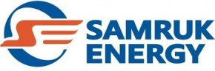

Kazakhstan’s Power Sector Market Analysis
January–SEPTEMBEr 2025

Prepared by: Market Analysis and Development Department
Contact details: 8 (7172) 55-30-67

OCTOBER 2025

Contents
1. Electricity generation in Kazakhstan’s UPS 3
1.1 Electricity regions by regions of the RK …………………………………………………..3
1.2 Electricity generation by energy holding companies and major power-producing companies..3
1.3 Electricity generation by power-producing companies of Samruk-Energy JSC 4
1.4 Shares of energy holding companies and major power-producing companies 5
2.1. Power sector performance 6
2.2 Electricity consumption by zones and regions 7
2.3 Electricity consumption by consumers of energy holding companies and major power-producing companies
2.4 Electricity consumption by major consumers in Kazakhstan 8
2.5 Electricity export and import 10
3. Coal 10
4. Renewable energy sources 11
4.1 Target indicators for RES 11
4.2 RES indicators in the RK 11
4.3 Tariff for RES support
4.4 RES pass-through charge
4.5 Role of Samruk-Energy JSC in clean electricity generation 12

Electricity generation in Kazakhstan’s UPS

According to the System Operator, power plants in the Republic of Kazakhstan generated 89 941,2 mln. kWh of electricity in January–September 2025, which is 3 195,9 thous. kWh, or 3.7 percent, higher than in the same period of 2024.
mln.kWh
No. | Zone | Generation type | January-September |  | Δ  mln.kWh | Δ, %
No. | Zone | Generation type | 2024 | 2025 | Δ  mln.kWh | Δ, %
 | Kazakhstan | Total | 86 745,3 | 89 941,2 | 3 195,9 | 3,7
 | Kazakhstan | TPP | 64 618,2 | 65 358,5 | 740,3 | 1,1
 | Kazakhstan | GTPP | 8 792,1 | 10 686,0 | 1 893,9 | 21,5
 | Kazakhstan | HPP | 8 505,0 | 8 379,1 | -125,9 | -1,5
 | Kazakhstan | WPP | 3 210,1 | 3 774,5 | 564,4 | 17,6
 | Kazakhstan | SPP | 1 619,3 | 1 741,6 | 122,3 | 7,6
 | Kazakhstan | BGP | 0,6 | 1,5 | 0,9 | 150
1 | Northern | Total | 63 625,3 | 64 379,5 | 754,2 | 1,2
1 | Northern | TPP | 53 324,1 | 53 734,6 | 410,5 | 0,8
1 | Northern | GTPP | 2 427,5 | 2 354,6 | -72,9 | -3,0
1 | Northern | HPP | 5 503,7 | 5 479,1 | -24,6 | -0,4
1 | Northern | WPP | 1 876,6 | 2 283,9 | 407,3 | 21,7
1 | Northern | SPP | 492,8 | 525,8 | 33,0 | 6,7
1 | Northern | BGP | 0,6 | 1,5 | 0,9 | 150,0
2 | Southern | Total | 11 386,7 | 12 122,4 | 735,7 | 6,5
2 | Southern | TPP | 6 015,2 | 6 630,2 | 615,0 | 10,2
2 | Southern | HPP | 3 001,3 | 2 900,0 | -101,3 | -3,4
2 | Southern | GTPP | 141,1 | 236,5 | 95,4 | 67,6
2 | Southern | WPP | 1 105,3 | 1 143,1 | 37,8 | 3,4
2 | Southern | SPP | 1 123,8 | 1 212,6 | 88,8 | 7,9
3 | Western | Total | 11 733,3 | 13 439,3 | 1 706,0 | 14,5
3 | Western | TPP | 5 278,9 | 4 993,7 | -285,2 | -5,4
3 | Western | GTPP | 6 223,5 | 8 094,9 | 1 871,4 | 30,1
3 | Western | WPP | 228,2 | 347,5 | 119,3 | 52,3
3 | Western | SPP | 2,7 | 3,2 | 0,5 | 18,5

Electricity generation by regions of the Republic of Kazakhstan

During January–September 2025, a notable increase in electricity generation was recorded in Akmola, Aktobe, Almaty, Atyrau, East Kazakhstan, Zhambyl, Zhetysu, Kyzylorda, North Kazakhstan, Turkistan, and Ulytau regions compared with the same period in 2024.
Conversely, output declined in Abai, West Kazakhstan, Karaganda, Kostanay, Mangystau, and Pavlodar regions.

mln.kWh
No. | Region | January-September |  | Δ, mln.kWh | Δ, %
No. | Region | 2024 | 2025 | Δ, mln.kWh | Δ, %
1 | Akmola region | 3 814,10 | 4 483,70 | 669,60 | 17,56
2 | Aktobe region | 3 124,2 | 3 164,60 | 40,40 | 1,29
3 | Almaty region | 5 312,30 | 5 237,80 | -74,50 | -1,40
4 | Atyrau region | 5 990,3 | 7 989,20 | 1 998,90 | 33,37
5 | Abai region | 2 037,00 | 1 974,80 | -62,20 | -3,05
6 | East Kazakhstan region | 5 494,0 | 5 627,80 | 133,80 | 2,44
7 | Zhambyl region | 3 391,90 | 4 114,30 | 722,40 | 21,30
8 | Zhetysu region | 698,4 | 788,10 | 89,70 | 12,84
9 | West Kazakhstan region | 1 719,80 | 1 724,60 | 4,80 | 0,28
10 | Karaganda region | 9 089,5 | 9 060,60 | -28,90 | -0,32
11 | Kostanay region | 987,90 | 936,10 | -51,80 | -5,24
12 | Kyzylorda region | 381,1 | 403,20 | 22,10 | 5,80
13 | Mangystau region | 4 023,20 | 3 725,50 | -297,70 | -7,40
14 | Pavlodar region | 35 564,2 | 35 627,30 | 63,10 | 0,18
15 | North Kazakhstan region | 1 709,10 | 1 774,70 | 65,60 | 3,84
16 | Turkistan region | 1 603,0 | 1 579,00 | -24,00 | -1,50
17 | Ulytau region | 1 492,50 | 1 729,90 | 237,40 | 15,91
 | Total for the Republic of Kazakhstan | 86 745,3 | 89 941,2 | 3 195,90 | 3,68

Electricity generation by energy holding companies and major power-producing companies

In January–September 2025, electricity generation by energy holding companies and major power-producing companies totaled 36 688,3mln kWh, which is 1 610,9 mln kWh less than in the same period of 2024 (38 299,2 mln kWh). Their combined share in total electricity generation amounted to 44,2%.
mln.kWh
No. | Name | 2024 |  | 2025 |  | Δ 2025/2024
No. | Name | January-September | Share in the RK, | January-September | Share in the RK | mln.kWh | %
 | Total | 38 299,2 | 44,2% | 36 688,3 | 40,8% | -1 610,9 | -4,2%
1. | ERG | 14 146,0 | 16,3% | 13 842,5 | 15,4% | -303,5 | -2,1%
 | Pavlodar CHP-1  Aluminium of Kazakhstan JSC | 1 600,9 | 1,8% | 1 362,2 | 1,5% | -238,7 | -14,9%
 | Eurasian Energy Corporation JSC (EEC) | 10 476,9 | 12,1% | 10 513,1 | 11,7% | 36,2 | 0,3%
 | CHP of SSGPO JSC | 661,7 | 0,8% | 592,6 | 0,7% | -69,1 | -10,4%
 | PSU-37 PP of AFP of TNC Kazchrome | 199,5 | 0,2% | 188,1 | 0,2% | -11,4 | -5,7%
 | GTPP PP AFP TNC Kazchrome | 607,6 | 0,7% | 583,9 | 0,6% | -23,7 | -3,9%
 | Shymkent CHP-3  Z-Energoortalyk JSC | 599,4 | 0,7% | 602,6 | 0,7% | 3,2 | 0,5%
2. | Kazakhmys Energy LLP | 3 993,0 | 4,6% | 4 249,8 | 4,7% | 256,8 | 6,4%
 | Karaganda SDPP-2 | 2 516,6 | 2,9% | 2 650,6 | 2,9% | 134,0 | 5,3%
 | Balkhash CHP | 741,3 | 0,9% | 736,8 | 0,8% | -4,5 | -0,6%
 | Zhezkazgan CHP | 735,1 | 0,8% | 862,4 | 1,0% | 127,3 | 17,3%
3. | KazZinc LLP | 2 450,9 | 2,8% | 2 523,2 | 2,8% | 72,3 | 2,9%
 | Bukhtarminsk HPP  KazZinc LLP | 2 305,4 | 2,7% | 2 372,4 | 2,6% | 67,0 | 2,9%
 | “LK HPP Company” LLP | 145,5 | 0,2% | 150,8 | 0,2% | 5,3 | 3,6%
4. | Qarmet JSC | 1 755,2 | 2,2% | 1821,8 | 2,2% | 66,6 | 3,8%
 | CHP-2 of Qarmet JSC | 1484,7 | 1,9% | 1597,2 | 2,0% | 112,5 | 7,6%
 | PVS-CHP of Qarmet JSC | 270,5 | 0,3% | 224,6 | 0,3% | -45,9 | -17,0%
5. | KKS LLP | 4 028,9 | 5,1% | 3692,9 | 4,6% | -336,0 | -8,3%
 | Ust-Kamenogorsk CHP JSC | 1220,0 | 1,6% | 1226,3 | 1,5% | 6,3 | 0,5%
 | CHP-1 of Karaganda-EnergoCenter LLP | 53,9 | 0,1% | 59,1 | 0,1% | 5,2 | 9,6%
 | CHP-3 of Karaganda-EnergoCenter LLP | 2755,0 | 3,5% | 2407,5 | 3,0% | -347,5 | -12,6%
6. | Central Asian Electric Power Corporation JSC (CAEPCO) | 3 780,2 | 4,8% | 3704,9 | 4,6% | -75,3 | -2,0%
 | CHP-2 of PavlodarEnergo JSC | 312,0 | 0,4% | 319,8 | 0,4% | 7,8 | 2,5%
 | CHP-3 of PavlodarEnergo JSC | 1907,2 | 2,4% | 1801,6 | 2,2% | -105,6 | -5,5%
 | PPCHP-2 of SevKazEnergo LLP | 1561,0 | 2,0% | 1583,5 | 2,0% | 22,5 | 1,4%
7. | Zhambyl SDPP JSC | 2294,2 | 2,9% | 2621,9 | 3,2% | 327,7 | 14,3%
8. | Oil and gas enterprises | 3 930,1 | 5,0% | 5193,7 | 6,4% | 1 263,6 | 32,2%

1.3 Electricity generation by Samruk-Energy JSC’s power-producing companies

In January–September 2025, Samruk-Energy JSC’s power plants generated 29 407,5 mln kWh of electricity, the increase in electricity generation compared to the same period in 2024 amounted to 112,6 million kWh, or 0,4%.
mln.kWh
No. | Name | 2024 |  | 2025 |  | Δ 2025/2024
No. | Name | January-September | Share in the RK, % | January-September | Share in the RK, % | mln.kWh | %
 | “Samruk-Energy” JSC | 29 294,9 | 33,8% | 29 407,5 | 32,7% | 112,6 | 0,4%
1 | “APP” JSC | 3 807,8 | 4,4% | 3 726,5 | 4,1% | -81,3 | -2,1%
2 | Ekibastuz SDPP-1 LLP | 16 776,0 | 19,3% | 17 406,8 | 19,4% | 630,8 | 3,8%
3 | Ekibastuz SDPP-2 JSC | 4 166,7 | 4,8% | 3 910,4 | 4,3% | -256,3 | -6,2%
4 | Shardarinskaya HPP JSC | 460,2 | 0,5% | 397,9 | 0,4% | -62,3 | -13,5%
5 | Moynak HPP JSC | 817,1 | 0,9% | 791,4 | 0,9% | -25,7 | -3,1%
6 | Samruk-Green Energy LLP | 15,2 | 0,0% | 15,8 | 0,0% | 0,58 | 3,8%
7 | Shelek WPP of Energia Semirechya LLP | 163,0 | 0,2% | 157,3 | 0,2% | -5,72 | -3,5%
8 | First Wind Power Plant LLP | 97,1 | 0,1% | 104,8 | 0,1% | 7,7 | 8,0%
9 | AES Ust-Kamenogorsk HPP LLP | 1 395,6 | 1,6% | 1 405,7 | 1,6% | 10,1 | 0,7%
10 | AES Shulbinsk HPP LLP | 1 596,2 | 1,8% | 1 490,9 | 1,7% | -105,3 | -6,6%

1.4 Shares of energy holding companies and large power-producing enterprises in Kazakhstan’s electricity generation

As shown in the chart below, Samruk-Energy JSC continues to hold a leading position in Kazakhstan’s electricity market, accounting for 32,7% of total power generation.

- Electricity consumption in Kazakhstan’s UPS

2.1. Performance results of the industrial sector for January–September 2025

In January–September 2025, Kazakhstan’s Industrial Production Index (IPI) reached 107,4%.
Output increased by 9,3% in mining, 6,2 % in manufacturing, and 2,1% in the supply of electricity, gas, steam, hot water and air conditioning.
The strongest growth was recorded in Atyrau, Zhambyl, North Kazakhstan, and Turkistan regions, as well as in Almaty and Shymkent cities.

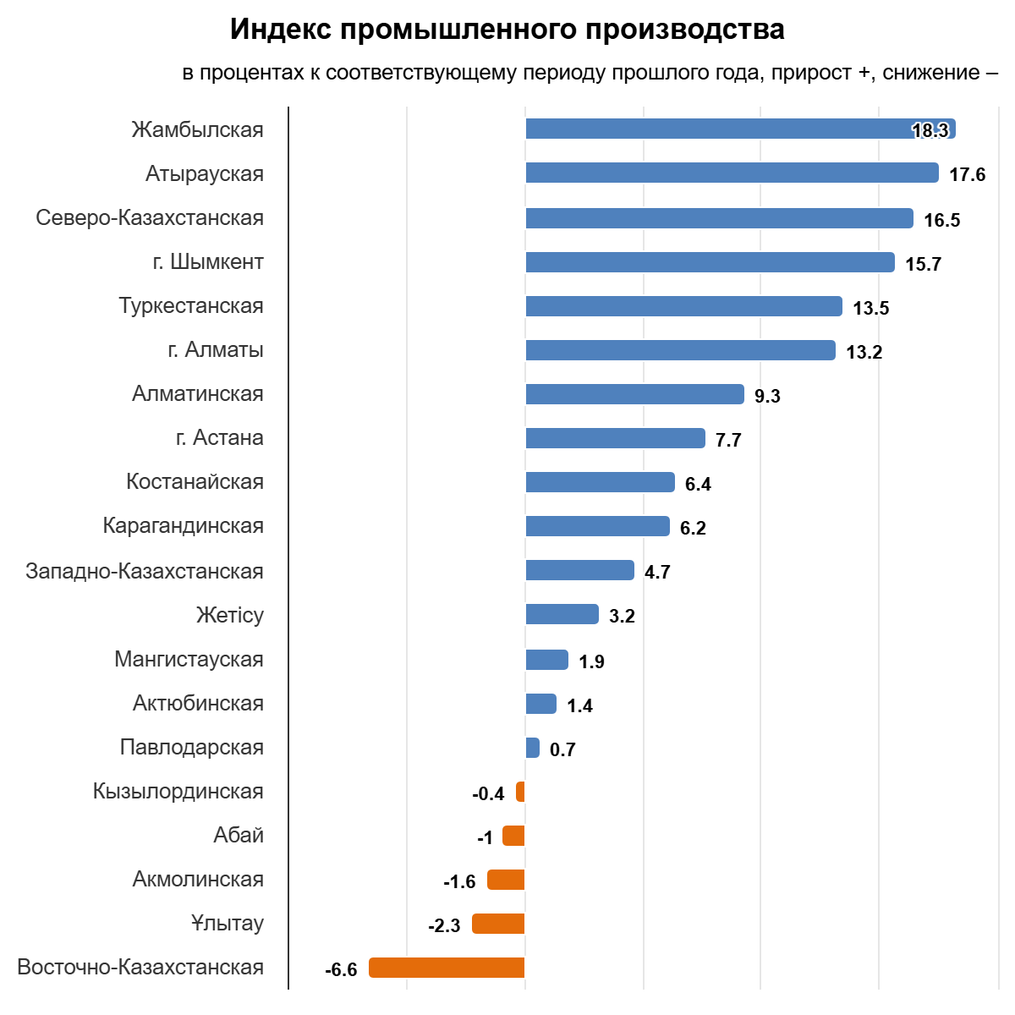

2.2 Electricity consumption by zones and regions

According to the System Operator, in January–September 2025 electricity consumption in the Republic increased by 3 685,5 mln.kWh , or by 4,2 %, compared with the same period in 2024. In the western and southern zones of the republic, consumption increased by 15% and 9,3%, respectively, while in the northern zone it decreased by 0,1%.

mln.kWh
No. | Description | January-September |  | Δ,  mln.kWh | Δ, %
No. | Description | 2024 | 2025 | Δ,  mln.kWh | Δ, %
 | Kazakhstan | 87 735,3 | 91 420,8 | 3 685,5 | 4,2
1 | Northern zone | 55 094,7 | 55 062,1 | -32,6 | -0,1
2 | Western zone | 12 002,4 | 13 798,8 | 1 796,4 | 15,0
3 | Southern zone | 20 638,2 | 22 559,9 | 1 921,7 | 9,3
 | Including by regions
1 | Akmola region | 7 529,2 | 7 809,3 | 280,1 | 3,7
2 | Aktobe region | 4 631,7 | 4 839,1 | 207,4 | 4,5
3 | Almaty region | 8 389,6 | 8 704,0 | 314,3 | 3,7
4 | Atyrau region | 5 158,4 | 5 415,9 | 257,5 | 5,0
5 | Abai region | 9 147,7 | 9 728,6 | 580,9 | 6,4
6 | East Kazakhstan region | 6 078,6 | 7 780,1 | 1 701,6 | 28,0
7 | Zhetysu region | 2 439,7 | 2 466,6 | 26,9 | 1,1
8 | Zhambyl region | 5 605,7 | 5 186,3 | -419,4 | -7,5
9 | West Kazakhstan region | 1 201,5 | 1 252,8 | 51,3 | 4,3
10 | Karaganda region | 3 649,0 | 4 289,2 | 640,2 | 17,5
11 | Kostanay region | 1 792,5 | 1 799,8 | 7,3 | 0,4
12 | Kyzylorda region | 11 274,2 | 11 033,5 | -240,7 | -2,1
13 | Mangystau region | 3 478,9 | 3 442,9 | -35,9 | -1,0
14 | Pavlodar region | 1 580,3 | 1 660,3 | 80,0 | 5,1
15 | North Kazakhstan region | 4 131,3 | 4 218,9 | 87,6 | 2,1
16 | Turkistan region | 14 538,0 | 14 697,2 | 159,2 | 1,1
17 | Ulytau region | 1252,2 | 1 261,5 | 9,2 | 0,7
2.3 Electricity consumption by major energy supply companies
In January–September 2025, electricity consumption by major energy supply companies amounted to 30 385,8 mln kWh.
mln.kWh
No. | Name | January-September
No. | Name | 2025
 | Total | 30 385,8
1. | Pavlodar REC | 1 285,2
2. | OESK JSC | 2 715,9
3. | Karagandy Zharyk | 1 837,9
4. | EPK-forfait LLP | 993,0
5. | Astana REC JSC | 3 360,2
6. | Kokshetau Energo LLP | 1 257,8
7. | North-Kazakhstan REC JSC | 916,6
8. | Alatau Zharyk Company JSC | 7 692,6
9. | Zhambyl Electricity Grids LLP | 1 371,4
10. | Ontustik Zharyk Transit LLP | 3 703,8
11. | Kzylorda REC | 1 147,0
12. | Energosistema LLP | 1 196,2
13. | Atyrau Zharyk JSC | 1 493,0
14. | Mangistau REC JSC | 1 415,2

Electricity consumption by Samruk-Energy JSC companies rose by 1 249 mln kWh, or 17,8 %, in January–September 2025 versus the same period in 2024.
mln.kWh
No. | Name | January-September |  | Δ, mln.kWh | Δ, %
No. | Name | 2024 | 2025 | Δ, mln.kWh | Δ, %
 | Samruk-Energy JSC | 7 008,7 | 8 257,6 | 1 249 | 17,8
1. | Bogatyr-Komir LLP | 221,8 | 215,7 | -6,1 | -2,8
2. | Alatau Zharyk Company JSC | 763,4 | 8 042 | 7 278,6 | 953,5
3. | AlmatyEnergoSbyt LLP | 6 023,5 | - | -6 023,5 | -100

2.4 Electricity consumption by large consumers in Kazakhstan
In January–September 2025, electricity consumption by large consumers increased by 1 896, 1 mln kWh, or 6,7%, compared with the same period in 2024.
mln.kWh
No. | Consumer | January-September |  | Δ, mln.kWh | Δ, %
No. | Consumer | 2024 | 2025 | Δ, mln.kWh | Δ, %
1 | Qarmet JSC | 2 247,1 | 2 266,7 | 19,6 | 0,9
2 | AFP (Aksu) JSC, TNC Kazchrome | 4 006,3 | 3 824,6 | -181,7 | -4,5
3 | Kazakhmys Smelting LLP | 755,3 | 924,3 | 169,0 | 22,4
4 | KazZinc LLP | 2 048,8 | 1 997,3 | -51,4 | -2,5
5 | Sokolov-Sarbai GPO JSC | 1 072,1 | 993,3 | -78,8 | -7,3
6 | Kazakhmys Corporation LLP | 1 024,9 | 1 104,4 | 79,5 | 7,8
7 | AFP (Aktobe) JSC, TNC Kazchrome | 2 583,3 | 2 720,1 | 136,9 | 5,3
8 | KAZ Minerals Bozshakol LLP | 646,1 | 816,5 | 170,4 | 26,4
9 | KAZ Minerals Aktogay LLP | 1 209,0 | 1 542,7 | 333,7 | 27,6
10 | YDD Corporation LLP | 739,3 | 413,2 | -326,1 | -44,1
11 | Ust-Kamenogorsk Titanium and Magnesium Plant JSC (in retail market since August) | 511,7 | 330,3 | -181,4 | -35,4
12 | NCOC | 696,6 | 878,2 | 181,6 | 26,1
12 | Atyrau Oil Refinery LLP | 654,8 | 622,5 | -32,4 | -4,9
12 | Tengizchevroil LLP | 1 913,1 | 3 443,2 | 1 530,1 | 80,0
13 | PAZ (Pavlodar Aluminium Plant) JSC | 750,8 | 766,1 | 15,3 | 2,0
14 | Kazakhstan Electrolytic Plant JSC | 2 814,6 | 2 797,8 | -16,9 | -0,6
15 | NC Kazakhstan Temir Zholy JSC | 2 612,3 | 2 622,6 | 10,3 | 0,4
16 | KEGOC JSC | 4 921,2 | 5 039,4 | 118,2 | 2,4
Total |  | 28 234,9 | 31 207,2 | 33 103,3 | 1 896,1

2.5Electricity exports and imports by major market participants

To balance electricity generation and consumption, the System Operator reported that in January–September 2025 exports to the Russian Federation amounted to 1 575,4 mln kWh, while imports from the Russian Federation totaled 1 016,6 mln kWh.

mln.kWh
Name | January-September |  | Δ, mln. kWh | Δ, %
Name | 2024 | 2025 | Δ, mln. kWh | Δ, %
Exports
"KEGOC" JSC – INTER RAO PJSC (balancing market) | 1 248,0 | 1 575,4 | 327,4 | 26,2%
FSC for RES – Power plant of Kyrgyzstan JSC | 905,6 | 950,2 | 44,6 | 4,9%
Imports
INTER RAO PJSC – Inter RAO-Kazakhstan LLP | 322,2 | 12,3 | -309,9 | -96,2%
INTER RAO PJSC – Inter RAO-Kazakhstan LLP – FSC for RES LLP | 1 408,0 | 2 127,2 | 719,2 | 51,1%
INTER RAO PJSC – KEGOC JSC (balancing market) | 1 335,1 | 1 016,6 | -318,5 | -23,9%
Transit Russia–Kyrgyzstan
INTER RAO PJSC – Power Plant of Kyrgyzstan JSC | 73,3 | 148,8 | 75,6 | 103,2%
INTER RAO PJSC – SOLARCOIN LLP | 179,5 | 96,1 | -83,4 | -46,5%

- Coal

According to the Bureau of National Statistics, Kazakhstan produced 81 188,5 thous. tons of hard coal in January–September 2025, which is 5,9 % higher than in the same period of 2024 (76 689,8 thous. tons).
thous.tons
№ п/п | Region | January-September |  | Δ, thous.tons | Δ, %
№ п/п | Region | 2024 | 2025 | Δ, thous.tons | Δ, %
1 | Pavlodar | 48 058,5 | 48 812,5 | 754,0 | 1,6%
2 | Karaganda | 22 670,9 | 26 011,2 | 3 340,3 | 14,7%
3 | East-Kazakhstan | 20 | 9,7 | -10,3 | -0,5
4 | Abai | 5 013,0 | 4 714,2 | -298,8 | -6%
 | Total across the RK | 76 689,8 | 81 188,5 | 4 498,7 | 5,9%

In January–September 2025, Bogatyr Komir LLP produced 32 165 thous. tons of coal, 3,1% more than in the same period of 2024 (31 207 thous. tons).
During the same period, total coal sales amounted to 31 885 thous. tons, including 24 521 thous. tons for the domestic market of Kazakhstan, 368 thous. tons less than in January–September 2024 (24 889 thous. tons), and 7 364 thous. tons for export to the Russian Federation, 12,7 % higher than in the corresponding period of 2024 (6 535 thous. tons).
In January–September 2025, Bogatyr Komir LLP reported a 1.5% increase in coal sales, up 461 thousand tons compared to the same period in 2024.
thous.tons
No. | Region | January-September |  | Δ, thous.tons | Δ, %  2024/2023
No. | Region | 2024 | 2025 | Δ, thous.tons | Δ, %  2024/2023
Total for the domestic market of the RK |  | 24 889 | 24 521 | -368 | -1,5%
Total for export to the RF |  | 6 535 | 7 364 | 829 | 12,7%
TOTAL |  | 31 424 | 31 885 | 461 | 1,5%

4. Renewable energy sources

Target indicators for renewable energy

Since adopting the strategy for transitioning to a “green economy,” Kazakhstan’s electricity sector has undergone significant reform.
The government has implemented the necessary support measures to develop the renewable energy sector (hereinafter – RES) in order to achieve the established target indicators:
- 3% share of RES in total electricity generation by 2020 (achieved);
- 15% share of RES in total electricity generation by 2030;
- 50% share of alternative energy and RES in total electricity generation by 2050.
Given Kazakhstan’s substantial RES resource potential, as well as the supportive conditions created for RES development, installed capacity of RES facilities has increased nearly elevenfold over the past seven years.

4.2.RES indicators in the RK

According to the System operator, electricity supplied to Kazakhstan’s UPS by RES facilities (SPP, WPP, biogas plants, and small HPPs) amounted to 13 896 mln kWh in January–September 2025. Compared with January–September 2024 (432,4 mln kWh), this represents an increase of 589.7 mln kWh, or 11.5%.
mln.kWh
No. | Description | 2024 |  | 2025 |  | Δ, mln. kWh | Δ, %
No. | Description | January-September | Share in the RK, % | January-September | Share in the RK, % | Δ, mln. kWh | Δ, %
1 | Generation in the RK | 78 284,8 | 100% | 81 103,9 | 100% | 2 819,1 | 3,6%
2 | RES generation in the RK | 5 142,2 | 6,6% | 5731,9 | 7,1% | 589,7 | 11,5%

4.3 Role of Samruk-Energy JSC in clean electricity generation
Electricity generation from Samruk-Energy’s renewable energy facilities (solar, wind and small hydropower plants) totaled 413,1 mln. kWh in January–September 2025, down 4,5% compared to the same period in 2024 (432,4 mln. kWh).
The share of Samruk-Energy’s renewable generation, including small hydropower plants, accounted for 6,4% of total renewable electricity generation in Kazakhstan for the period January–September 2025, compared to 7,5% in 2024.
mln.kWh
No. | Name | 2024 |  | 2025 |  | Δ, mln.kWh | Δ, %
No. | Name | January-September | Share in the RK, % | January-September | Share in the RK, % | Δ, mln.kWh | Δ, %
 | SE RES including: | 432,4 | 7,5% | 413,1 | 6,4% | -19,3 | -4,5%
1 | Cascade of small HPPs of APP JSC 43,7MW | 157,0 | 2,7% | 135,1 | 2,1% | -21,9 | -13,9%
2 | Samruk-Green Energ 2MW SPP + 1MW SPP+ 0,4MW SPP | 4,4 | 0,1% | 4,6 | 0,1% | 0,2 | 4,5%
3 | Samruk-Green Energy LLP 5 MW WPP Shelek | 10,9 | 0,2% | 11,3 | 0,2% | 0,4 | 3,7%
4 | 45 MW WPP of First Wind Power Plant | 97,1 | 1,7% | 104,8 | 1,6% | 7,7 | 7,9%
5 | 60 MW WPP Shelek of Energia Semirechya LLP | 432,4 | 7,5% | 413,1 | 6,4% | -19,3 | -4,5%

