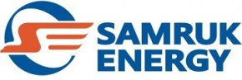

Kazakhstan’s Power Sector Market Analysis
January–JUNE 2026

Prepared by: Market Analysis and Development Department
Contact details: 8 (7172) 55-30-67

AUGUST 2026

Contents
1. Electricity generation in Kazakhstan’s UPS 3
1.1 Electricity generation by "Samruk-Energy" JSC power-producing companies..…….……..3
2.1. Performance results of the industrial sector for January–December 2025.……………..4
2.2 Electricity consumption by zones 5
Coal ……………………………………………………………………………….……………………………….
3. Renewable energy sources 6
3.1 Target indicators for RES 6
3.2 RES indicators in the RK 6
3.3 Role of Samruk-Energy JSC in clean electricity generation 7

Electricity generation in Kazakhstan’s UPS

According to the System Operator, power plants in the Republic of Kazakhstan generated 63,120.1 million kWh of electricity in January–June 2026, up 882.6 million kWh, or 1.4%, compared to the same period in 2025.
mln.kWh
No. | Zone | Generation type | January-June |  | Δ  mln.kWh | Δ, %
No. | Zone | Generation type | 2025 | 2026 | Δ  mln.kWh | Δ, %
 | Kazakhstan | Total | 62 237,5 | 63 120,1 | 882,6 | 1,4
 | Kazakhstan | TPP | 45812,3 | 46752,5 | 940,2 | 2,1
 | Kazakhstan | GTPP | 7143,1 | 6935,1 | -208,0 | -2,9
 | Kazakhstan | HPP | 5601,4 | 4929,5 | -671,9 | -12,0
 | Kazakhstan | WPP | 2610,6 | 3371,2 | 760,6 | 29,1
 | Kazakhstan | SPP | 1069,4 | 1130,3 | 60,9 | 5,7
 | Kazakhstan | BGP | 0,7 | 1,5 | 0,8 | 114,3
1 | Northern | Total | 44 737,1 | 45 657,3 | 920,2 | 2,1
1 | Northern | TPP | 37500,2 | 38177,1 | 676,9 | 1,8
1 | Northern | GTPP | 1623,5 | 1591,9 | -31,6 | -1,9
1 | Northern | HPP | 3677,2 | 3316,7 | -360,5 | -9,8
1 | Northern | WPP | 1597,5 | 2224,8 | 627,3 | 39,3
1 | Northern | SPP | 338,0 | 345,3 | 7,3 | 2,2
1 | Northern | BGP | 0,7 | 1,5 | 0,8 | 114,3
2 | Southern | Total | 8 588,3 | 8 546,6 | -41,7 | -0,5
2 | Southern | TPP | 5006,4 | 4856,1 | -150,3 | -3,0
2 | Southern | HPP | 1924,2 | 1612,8 | -311,4 | -16,2
2 | Southern | GTPP | 146,2 | 560,6 | 414,4 | 283,4
2 | Southern | WPP | 781,6 | 792,0 | 10,4 | 1,3
2 | Southern | SPP | 729,9 | 725,1 | -4,8 | -0,7
3 | Western | Total | 8 912,1 | 8 916,2 | 4,1 | 0,0
3 | Western | TPP | 3305,7 | 3719,3 | 413,6 | 12,5
3 | Western | GTPP | 5373,4 | 4782,6 | -590,8 | -11,0
3 | Western | WPP | 231,5 | 354,4 | 122,9 | 53,1
3 | Western | SPP | 1,5 | 59,9 | 58,4 | 3893,3

1.1 Electricity generation by Samruk-Energy JSC’s power-producing companies

Electricity generated by Samruk-Energy JSC’s power generation entities in January–June 2026 amounted to 20,286.5 million kWh, down 221 million kWh, or 1.1%, compared to the same period in 2025.

mln.kWh
No. | Name | 2025 |  | 2026 |  | Δ 2026/2025
No. | Name | January-June | Share in the RK, % | January-March | Share in the RK, % | mln.kWh | %
 | “Samruk-Energy” JSC | 20 507,9 | 33,0% | 20 286,5 | 32,1% | -221,4 | -1,1%
1 | “APP” JSC | 2 702,6 | 4,3% | 2 578,0 | 5,5% | -124,6 | -4,6%
2 | Ekibastuz SDPP-1 LLP | 11 804,3 | 19,0% | 12 253,2 | 19,4% | 448,9 | 3,8%
3 | Ekibastuz SDPP-2 JSC | 2 992,1 | 4,8% | 2 825,2 | 4,5% | -166,9 | -5,6%
4 | Shardarinskaya HPP JSC | 348,0 | 0,6% | 296,5 | 0,5% | -51,5 | -14,8%
5 | Moynak HPP JSC | 491,5 | 0,8% | 423,5 | 0,7% | -68,0 | -13,8%
6 | Samruk-Green Energy LLP | 11,0 | 0,0% | 10,7 | 0,0% | -0,34 | -3,1%
7 | Shelek WPP of Energia Semirechya LLP | 114,5 | 0,2% | 111,3 | 0,2% | -3,16 | -2,8%
8 | First Wind Power Plant LLP | 82,2 | 0,1% | 65,5 | 0,1% | -16,7 | -20,3%
9 | AES Ust-Kamenogorsk HPP LLP | 944,2 | 1,5% | 828,0 | 1,3% | -116,2 | -12,3%
10 | AES Shulbinsk HPP LLP | 1017,5 | 1,6% | 894,6 | 1,4% | -122,9 | -12,1%

- Electricity consumption in Kazakhstan’s UPS

2.1. Performance Results of the Industrial Sector in January–June 2026
In January–June 2026, Kazakhstan’s Industrial Production Index (IPI) stood at 103.5%.
Growth was recorded in the manufacturing sector, up 9.8%; in electricity, gas, steam, hot water and air conditioning supply, up 10.5%; and in water supply, wastewater collection and treatment, waste management and remediation activities, up 9.8%. At the same time, a decline in output was observed in the mining sector, down 4%.

Among the regions, the strongest growth was recorded in the Almaty, Zhambyl, Zhetysu, North Kazakhstan, Ulytau and Turkistan regions, as well as in the cities of Astana, Almaty and Shymkent.
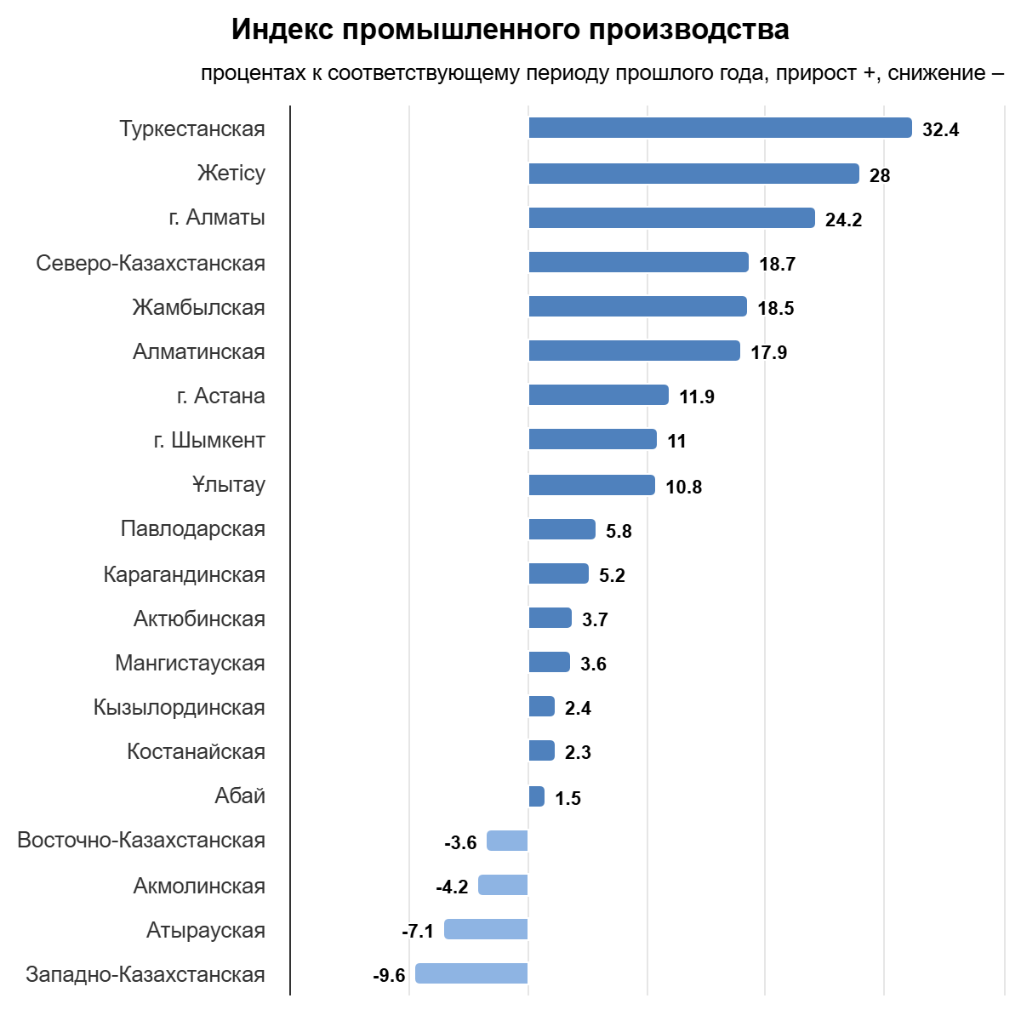

2.2 Electricity consumption by zones
According to the System Operator, electricity consumption in the Republic of Kazakhstan increased by 1,340.3 million kWh, or 2.2%, in January–June 2026 compared to the same period in 2025. Consumption increased by 2.6% in the Northern Zone and by 2.7% in the Southern Zone, while in the Western Zone it decreased by 0.5%.
mln.kWh
No. | Description | January-June |  | Δ,  mln.kWh | Δ, %
No. | Description | 2025 | 2026 | Δ,  mln.kWh | Δ, %
 | Kazakhstan | 61 811,2 | 63 151,5 | 1 340,3 | 2,2
1 | Northern zone | 37 768,1 | 38 744,1 | 976,0 | 2,6
2 | Western zone | 9 129,2 | 9 087,8 | -41,4 | -0,5
3 | Southern zone | 14 913,9 | 15 319,6 | 405,7 | 2,7
 | Including by regions
1 | Akmola | 6 055,3 | 6 418,4 | 363,1 | 6,0
2 | Aktobe | 3 634,1 | 3 646,2 | 12,1 | 0,3
3 | Almaty | 6 499,6 | 6 797,6 | 298,0 | 4,6
4 | Atyrau | 5 124,7 | 4 873,9 | -250,8 | -4,9
5 | Abai | 1 714,2 | 1 789,0 | 74,8 | 4,4
6 | East Kazakhstan | 3 632,9 | 3 326,5 | -306,4 | -8,4
7 | Zhetysu | 827,0 | 855,7 | 28,7 | 3,5
8 | Zhambyl | 2 837,2 | 2 740,7 | -96,5 | -3,4
9 | West Kazakhstan | 1 226,6 | 1 311,7 | 85,1 | 6,9
10 | Karaganda | 7 499,6 | 7 678,6 | 179,0 | 2,4
11 | Kostanay | 2 399,1 | 2 436,2 | 37,1 | 1,5
12 | Kyzylorda | 1 121,4 | 1 162,3 | 40,9 | 3,6
13 | Mangystau | 2 777,9 | 2 902,2 | 124,3 | 4,5
14 | Pavlodar | 10 000,0 | 10 573,2 | 573,2 | 5,7
15 | North Kazakhstan | 886,9 | 921,1 | 34,2 | 3,9
16 | Turkistan | 3 628,6 | 3 763,3 | 134,7 | 3,7
17 | Ulytau | 1 946,0 | 1 954,9 | 8,9 | 0,5

Coal

According to the Bureau of National Statistics, Kazakhstan produced 51,708 thousand tonnes of coal in January–June 2026, down 1.3% compared to the same period in 2025 (52,407.2 thousand tonnes).
thous.tons
№ п/п | Region | January-June |  | Δ, thous.tons | Δ, %
№ п/п | Region | 2025 | 2026 | Δ, thous.tons | Δ, %
1 | Pavlodar | 32 596,6 | 29 987,9 | -2 608,7 | -8%
2 | Karaganda | 15 830,7 | 17 134,6 | 1 303,9 | 8,2%
3 | East-Kazakhstan | 9,2 | 5,7 | -3,5 | -0,4
4 | Abai | 3 025,1 | 3 096,1 | 71 | 2,3%
 | Total across the RK | 52 407,4 | 51 708 | -699,4 | -1,3%

In January–June 2026, Bogatyr Komir LLP produced 21,173 thousand tonnes of coal, down 0.2% compared to the same period in 2025 (21,206 thousand tonnes).

3. Renewable energy sources

3.1. Target indicators for renewable energy

Since adopting the strategy for transitioning to a “green economy,” Kazakhstan’s electricity sector has undergone significant reform.
The government has implemented the necessary support measures to develop the renewable energy sector (hereinafter – RES) in order to achieve the established target indicators:
- 3% share of RES in total electricity generation by 2020 (achieved);
- 15% share of RES in total electricity generation by 2030;
- 50% share of alternative energy and RES in total electricity generation by 2050.
Given Kazakhstan’s substantial RES resource potential, as well as the supportive conditions created for RES development, installed capacity of RES facilities has increased nearly elevenfold over the past seven years.

3.2.RES indicators in the RK
According to the System Operator, electricity supplied to the Unified Power System of Kazakhstan by renewable energy facilities (solar power plants, wind power plants, biogas plants and small hydropower plants) amounted to 5,170.3 million kWh in January–June 2026. Compared to January–June 2025 (4,276.8 million kWh), this represented an increase of 893.5 million kWh, or 20.9%.
mln.kWh
No. | Description | 2025 |  | 2026 |  | Δ, mln. kWh | Δ, %
No. | Description | January-March | Share in the RK, % | January-March | Share in the RK, % | Δ, mln. kWh | Δ, %
1 | Generation in the RK | 62 237,5 | 100% | 63 120,1 | 100% | 882,6 | 1,4%
2 | RES generation in the RK | 4276,8 | 6,9% | 5170,3 | 8,2% | 893,5 | 20,9%

3.3 Role of Samruk-Energy JSC in clean electricity generation

Electricity generation by Samruk-Energy JSC’s renewable energy facilities (solar power plants, wind power plants and small hydropower plants) amounted to 269.8 million kWh in January–June 2026, down 5% compared to the same period in 2025 (283.9 million kWh).
In January–June 2026, electricity generated by Samruk-Energy JSC’s renewable energy facilities, including small hydropower plants, accounted for 5.2% of total electricity generated by renewable energy facilities in the Republic of Kazakhstan, compared to 6.6% in 2025.
mln.kWh
No. | Name | 2025 |  | 2026 |  | Δ, mln.kWh | Δ, %
No. | Name | January-June | Share in the RK, % | January-June | Share in the RK, % | Δ, mln.kWh | Δ, %
 | SE RES including: | 283,9 | 6,6% | 269,8 | 5,2% | -14,1 | -5,0%
1 | Cascade of small HPPs of APP JSC 43,7MW | 76,2 | 1,8% | 81,4 | 1,6% | 5,2 | 6,8%
2 | Samruk-Green Energ 2MW SPP + 1MW SPP+ 0,4MW SPP | 2,9 | 0,1% | 3,5 | 0,1% | 0,6 | 20,7%
3 | Samruk-Green Energy LLP 5 MW WPP Shelek | 8,1 | 0,2% | 8,1 | 0,2% | 0,0 | 0,0%
4 | 45 MW WPP of First Wind Power Plant | 82,2 | 1,9% | 65,5 | 1,3% | -16,7 | -20,3%
5 | 60 MW WPP Shelek of Energia Semirechya LLP | 114,5 | 2,7% | 111,3 | 2,2% | -3,2 | -2,8%

